Project 5
Due Sunday 3/4/2018 by 11:59 PM
No delay is accepted
For each day late submission 2 points penalty is incurred.
Copy/paste your Java classes to this document and drop it into the folder Project 5 on the blackboard.
If you have any question please email me at mbadii@pace.edu

Do not delete anything from this file. Just copy/paste your java classes under the word: Answer.

The program in the zipped file creates a database, and a table with some names (See the sample dialog).

Write a servlet program using the following html document to change names in the table (See the sample dialog)

<!--Do not change this html document-->
<!DOCTYPE html PUBLIC "-//W3C//DTD HTML 4.01 Transitional//EN" "http://www.w3.org/TR/html4/loose.dtd">
<html>
<head>
<meta http-equiv="Content-Type" content="text/html; charset=ISO-8859-1">
<title>Project 5</title>
</head>
<body>
<form action="http://localhost:8080/Project/Main">
<center>
<br><br>
Name:<input name="oldName" type="text" value="">
<br><br>
Change to:
<br><br>
Name: <input name="newName" type="text" value="">
<br><br>
&nbsp;&nbsp;&nbsp;&nbsp;&nbsp;&nbsp;&nbsp;&nbsp;&nbsp;<input type="Submit">
</center>
</form>
</body>
</html>

Note: You must not change this html document.
Note: The name of your java project in eclipse must be: Project with uppercase: P.

Note: The name of the Servlet class must be: Main.

A sample dialog:

First I run the java program that is in the folder: MakeTheDataBase. The grean lines are the inputs to the program.

Enter a first name, a space, a last name or enter word: end.
John Doe
Enter a first name, a space, a last name or enter word: end.
Adam Smith
Enter a first name, a space, a last name or enter word: end.
Jane Doe
Enter a first name, a space, a last name or enter word: end.
Mehdi Badii
Enter a first name, a space, a last name or enter word: end.
end
The content of the table: simple in the database: mydatabase is:
John Doe
Adam Smith
Jane Doe
Mehdi Badii

Note that every time you run this program it removes the database, creates a new database: mydatabase and creates a new table: simple.

Next I run my working program that you need to write. I enter the name: Dr No that is not in the table and Dr. Yes:

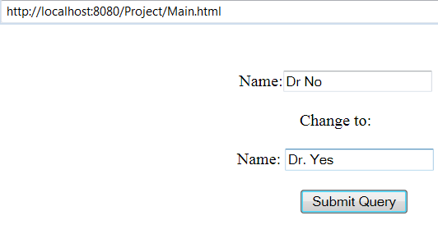

When I click on the button the display page from the servlet is:

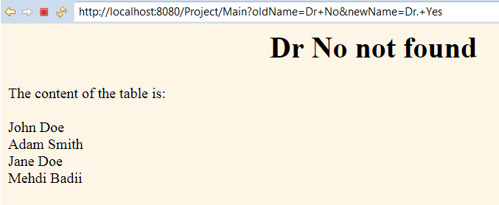

Now I go to the previous page and enter my name to change with the name: Rebecca Ferguson.

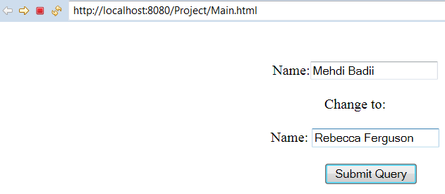

The display page from the servlet is:

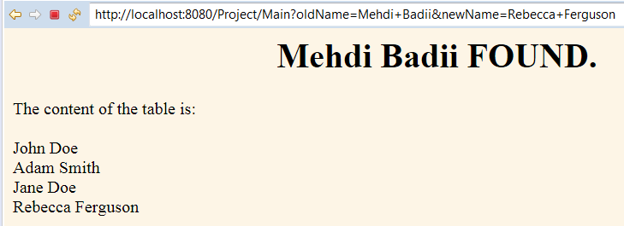

Answer:

import java.io.*;
import java.io.IOException;
import java.sql.*;
import java.sql.Connection;
import java.sql.DriverManager;
import javax.servlet.ServletException;
import javax.servlet.annotation.WebServlet;
import javax.servlet.http.HttpServlet;
import javax.servlet.http.HttpServletRequest;
import javax.servlet.http.HttpServletResponse;
import java.util.Vector;

/**
* Servlet implementation class Main
*/
@WebServlet("/Main")
public class Main extends HttpServlet {
private static final long serialVersionUID = 1L;

/**
* @see HttpServlet#HttpServlet()
*/
public Main() {
super();
// TODO Auto-generated constructor stub
}

/**
* @see HttpServlet#doGet(HttpServletRequest request, HttpServletResponse response)
*/
protected void doGet(HttpServletRequest request, HttpServletResponse response) throws ServletException, IOException {
// TODO Auto-generated method stub
//response.getWriter().append("Served at: ").append(request.getContextPath());

String html = "<html><title>Project 5</title><body bgcolor=\"#fdf5e6\">\n";

String oldName = request.getParameter("oldName");
String newName = request.getParameter("newName");

try {
Class.forName("com.mysql.jdbc.Driver").newInstance();
Connection con = DriverManager.getConnection("jdbc:mysql://localhost/?user=root&password=");
Statement stmt = con.createStatement();
stmt.execute("USE mydatabase");

Vector<String> names = new Vector<String>();

String query = "Select * from simple";
int count = 0;

if(oldName != null) {
ResultSet rs = stmt.executeQuery(query);
while(rs.next()) {
String name = rs.getString(1);
//System.out.println("Name retrieved - '" + name + "'");
if(name.equals(oldName)) {
names.add(newName);
query = "Update simple Set name='" + newName + "' Where name='" + oldName + "'";
count++;
}
else names.add(name);
}
html += "<h1 style='text-align:center;'>";
if(count != 0) {
stmt.executeUpdate(query);
html += oldName + " FOUND.</h1>";
}
else html += oldName + " not found.</h1><br/><br/>";

html += "The content of the table is:<br/><br/>";

for(int i = 0; i < names.size(); i++)
{
html += names.get(i).toString() + "<br/>";
}
}
} catch (Exception ex) {
System.out.println(ex);
System.exit(0);
}

html += "</body></html>";
PrintWriter out = response.getWriter();
out.println(html);
out.close();
}

/**
* @see HttpServlet#doPost(HttpServletRequest request, HttpServletResponse response)
*/
protected void doPost(HttpServletRequest request, HttpServletResponse response) throws ServletException, IOException {
// TODO Auto-generated method stub
doGet(request, response);
}

}

